BDCOM S8500E Installation Manual



Table of Contents
BDCOM S8500E Installation Manual 1
Chapter 1 Overview 3
1.1 Introduction to S8500E 3
1.2 Attributes of S8500E 3
1.3 Appearance of S8500E 4
1.4 ROHS Description 6
1.5 S8500E Hardware Composition 6
1.5.1 Cabinet 7
1.5.2 Machine Box 7
1.5.3 Single-Board Frame 10
1.5.4 Power Supply Distribution 12
1.6 Ventilation and Cooling System 13
1.7 Introduction to S8500E Single Board 14
1.7.1 Main Control Board (ES85-MSU-I) 16
1.7.2 Main Control Board (ES85-MSU-II) 17
1.7.3 48-port GE TX Port Module (ES85-48GT) 19
1.7.4 48-port GE SFP Port Module (ES85-48GS) 20
1.7.5 48-port GE TX/SFP Port Module (ES85-24GS24GT) 21
1.7.6 24-port GE SFP and 8-port 10GE SFP+ port module (ES85-24GS8TS) 22
1.7.7 24-port GE TX and 8-port 10GE SFP+ port module (ES85-24GT8TS) 23
1.7.8 16-port 10GE SFP+ Port Module (ES85-16TS) 24
1.7.9 4-port 40GE QSFP port module (ES85-4QS) 25
1.7.10 24-port GE TX and 8-port 10GE SFP+ 03 main control board (ES8503-MSU-24GT8TS) 26
1.7.11 24-port GE SFP and 8-port 10GE SFP+ 03 main control board (ES8503-MSU-24GS8TS) 28
Chapter 2 Installation Preparation 30
2.1 Safety Advice 30
2.1.1 Safety Advices for System Installation 30
2.1.2 Safety Advices for Removal 30
2.1.3 Electricity Security 31
2.1.4 Static Discharge Prevention 31
2.1.5 Laser Security 32
2.2 Requirements for Location Place 32
2.2.1 Requirements for Stand Installation 32
2.2.2 Ventilation Requirements 33
2.2.3 Temperature and Humidity 33
2.2.4 Cleanness Requirements 34
2.2.5 Power Requirements 35
2.3 Grounding Requirements for the System 36
2.3.1 Safe Grounding 36
2.3.2 Thunder Grounding 36
2.3.3 Electromagnetic-Compatible Grounding 36
2.3.4 EMI Precautions 37
2.3.5 Precautions for Optical Fiber Connection 38
2.4 Installation Tools 38
2.5 Requirements for Unpacking & Goods Examination 38
2.5.1 Cargo List 39
2.5.2 Recording the On-Site Log 40
Chapter 3 Installation of S8500E 41
3.1 Installation Procedures 41
3.2 Preparation before Installation 42
3.3 Installing the Switch’s Machine box 42
3.3.1 Precautions 42
3.3.2 Installation Procedures 43
3.4 Installing S8500E on the Cabinet 43
3.4.1 Precautions 43
3.4.2 Installation Procedures 43
3.5 Connecting the System and the Ground 44
3.5.1 Precautions 44
3.5.2 Grounding Procedures 44
3.5.3 Connecting the DC Power Supply to the Power Supply Module 44
3.5.4 Precautions 44
3.5.5 Connection Procedures 45
3.6 Connecting the AC Power Supply to the Power Supply Module 45
3.6.1 Precautions 45
3.6.2 Connection Procedures 45
3.7 Connecting the Cable of the Main Control Board 45
3.7.1 Connection Procedures 45
3.8 Removing the Single Board Away from S8500E 46
3.8.1 Procedures for Removing the Single Board 46
3.9 Reinstalling a Board on S8500E 47
3.9.1 Procedures for Reinstalling a Board 47
3.10 Connecting the Cables of the Outside Interface 47
3.10.1 Precautions 47
3.10.2 Connection Procedures 47
3.11 Packing the Cable 48
3.11.1 Precautions 48
3.11.2 Packing Procedures 48
3.12 Checking after Installation 48
3.12.1 Checking the Cabinet 48
3.12.2 Checking Cable Connection 48
3.12.3 Checking the Power Supply 48
Chapter 4 Common Trouble Shooting during Installation 50
4.1 General Procedures for Trouble Shooting during Installation 50
4.2 Trouble Shooting in Hardware Installation 51
4.2.1 Trouble Shooting in the Power Supply Module 51
4.2.2 Board Installation Troubles 51
Chapter 5 Appendix 53
5.1 Identifier, Package, Transmission and Storage of S8500E 53
5.1.1 Identifier of S8500E 53
5.1.2 Identifiers on the Outside Package 53
5.1.3 Production Origin 53
5.1.4 Product Type 53
5.1.5 Package 53
5.1.6 Basic Package Requirements 53
5.1.7 Package Materials 54
5.1.8 Shipping 54
5.1.9 Storage 54
5.2 Tools for Opening and Closing the Package Box 55
5.3 Others 55
5.3.1 Accessory Files 55
5.3.2 Accessory Cables 56

Overview
 To make description easy, BDCOM S8500E Series Switches is shortened as S8500E.

Introduction to S8500E
In recent years, Internet users increase explosively. Users are not satisfied with communications based on the telephone network. They wish telecom carriers to provide multimedia services like audio, data and pictures. The traditional bandwidth access mode cannot meet the increasing requirements for telecom services. The bandwidth access technology can bring great changes to people’s life and work.
Compared with ADSL and HFC, the Ethernet access mode has advantages like bandwidth and low cost. IP is the main service of the bandwidth MAN, while Ethernet is the direct mode to bear the IP service. No other specific devices need be added for the network and users, which reduces the cost of protocol transform. Meanwhile, the Ethernet access mode is much suitable to relatively-populated community users, which meets the access network optical trend. Hence, the Ethernet is widely applied to the bandwidth access field.
Facing this trend, BDCOM provides a business Ethernet solution, a kind of business-oriented Ethernet access solution. S8500E is a manageable bandwidth access aggregation device produced by BDCOM.
S8500E has the user management function and the multi-layer switching function. It provides large-capacity multilayer switching capability, the wire-speed user access management capacity and multiple charging modes. It provides carriers a mature and flexible operation mode.
S8500E can meet users' requirements to add single board and plug-ins, with manageable functions and rich QoS features.
S8500E supports the following services:
- Internet broadband access
- Large-capacity data exchange between MAN enterprises, within one enterprise, and campus networking

Attributes of S8500E
- Parallel development of wire-speed L2/L3 switchover and wire-speed access
- Flexibility and high performance obtained from ASIC wire-speed processing and the network processor
- High active-passive redundancy without restarting
- Proper switchover capacity and high port density
- Coexistence of multiple access modes
- Uniform user management
- Flexible charging mechanism
- RADIUS-based user broadband management and privilege control
- Easy non-Ethernet module expansibility provided by the standard switchover frame

Appearance of S8500E
S8500E has three models, S8506E, S8510E and S8503E. Their appearances are displayed below respectively.
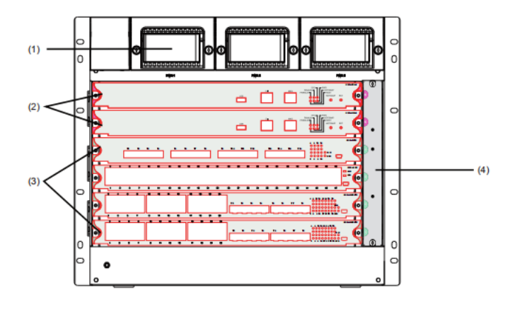
Figure 1-1 S8506E Appearance
(1) Power layer: AC or DC power modules can be configured.
(2) Main control module layer: 2 single board slots supporting 2 main control modules.
(3) Line card module layer: 4 single board slots supporting 4 service modules.
(4) Fan module layer: One fan module slot.

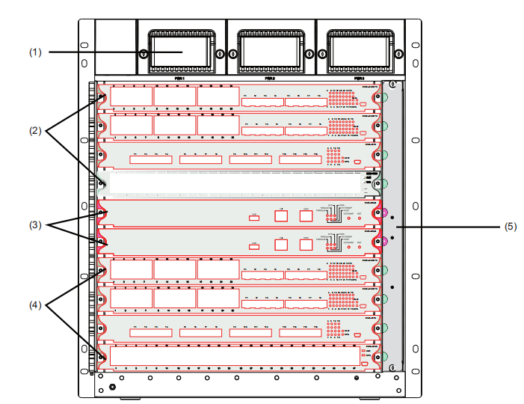
Figure 1-2 S8510E Appearance
(1) Power layer: AC or DC power modules can be configured.
(2) (4) Service module layer: 8 single board slots supporting 8 service modules.
(3) Main control module layer: 2 single board slots supporting 2 main control modules.
(5) Fan module layer: One fan module slot.

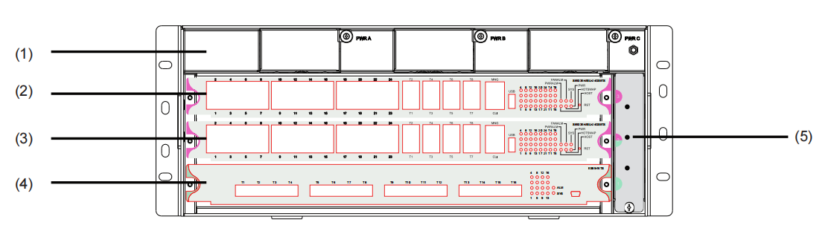
Figure 1-3 S8503E Appearance
(1) Power layer: AC or DC power modules can be configured.
(2) Main control module layer: 1 single board slot supporting 1 main control module.
(3) Main control /Service module layer: 1 single board slots supporting 1 main control module or 1 service module.
(4) Service module layer: 1 single board slot supporting 1 service module.
(5) Fan module layer: One fan module slot.

ROHS Description


S8500E Hardware Composition
The hardware system of S8500E consists of the machine box, power supply system, heat cooling system and systematic modules.
The machine box of S8506E has a net weight of 21.5KG; the power module has a net weight of 0.7KG; the single-board module has a net weight of 2.7KG. When all modules of S8506E are inserted, the net weight of S8506E is 38.4KG. The wooden box has a net weight of 13.6KG; the accessory box (cable) is 1KG. The gross weight after packaging is 53KG.
The machine box of S8510E has a net weight of 25.5KG; the power module has a net weight of 0.7KG; the single-board module has a net weight of 2.7KG. When all modules of S8510E are inserted, the net weight of S8510E is 53.2KG. The wooden box has a net weight of 16KG; the accessory box (cable) is 1KG. The gross weight after packaging is 70KG.
The machine box of S8503E has a net weight of 11.1KG; the power module has a net weight of 0.7KG; the single-board module has a net weight of 2.7KG. When all modules of S8503E are inserted, the net weight of S8503E is 20KG. The packaging carton has a net weight of 1.5KG; the accessory box (cable) is 1KG. The gross weight after packaging is 22.5KG.

Cabinet
S8500E should be installed on the 19-inch standard cabinet. BDCOM can provide the standard 19-inch cabinet, which has the following different specifications:
- 2.2m mental-plate cabinet (HeightxWidthxDepth = 2200x600mmx600mm)
- 2.0m mental-plate cabinet (HeightxWidthxDepth = 2000x600mmx600mm)
- 1.8m mental-plate cabinet (HeightxWidthxDepth = 1800x600mmx600mm)
- 1.6m mental-plate cabinet (HeightxWidthxDepth = 1600x600mmx600mm)

Machine Box
S8500E adopts the 19-inch standard machine box, whose specification varies with different models:
- S8506E: HeightxWidthxDepth = 397.2mmx482.6mmx370mm
- S8510E: HeightxWidthxDepth = 530.6mmx482.6mmx370mm
- S8503E: HeightxWidthxDepth = 177.5mmx482.6mmx376.2mm
The machine box of S8500E consists of the fan module layer, the functional module layer and the power supply layer.
The functional module layer is a single-board insertion box, which is the base to support each single board of S8500E.
The power supply layer is at the top of the machine box, which can be inserted with up to 3 AC/DC power modules. The power module has its own fan and adopts the air exhaust mode. The front template of the power supply has an air inlet, while the backplane of the machine box has an air outlet.
The fan module layer lies on the right of the machine box. The fan is on the fan module layer and it takes the air exhaust mode. The fan module can be taken out from the front of the machine box for maintenance, clearance or replacement.
Figure 1-4 S8500E Front View
(1) Power layer: AC or DC power modules can be configured.
(2) (4) Service module layer: 8 single board slots supporting 8 service modules.
(3) Main control module layer: 2 single board slots supporting 2 main control modules.
(5) Fan module layer: One fan module slot.

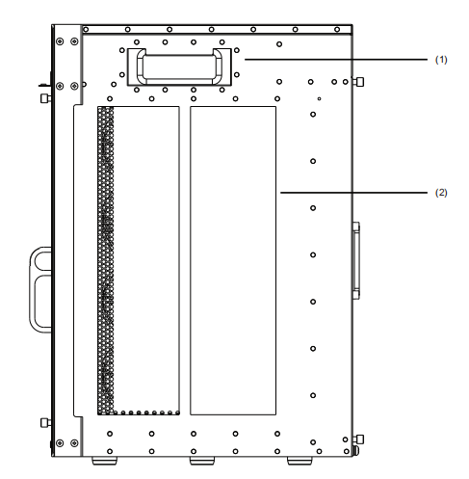
Figure 1-5 S8500E Side View
(1) Carrying handle: used to move the S8500E.
(2) Air outlet layer or air inlet layer: the cold air inlet of the system in the left side, and the hot air outlet in the right side.
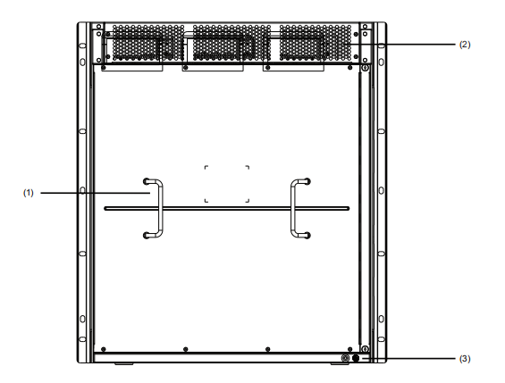
Figure 1-6 S8500E Back View
(1) Handle: the installing handle of the back panel.
(2) Power supply air outlet: the power supply has a fan.
(3) Grounding column: the system grounding column.

Single-Board Frame
The single-board frame consists of single-board slot and backplane.
S8503E has 3 single-board slots with the slot space of 40.6mm. Slot 3 can only be inserted with the ES8503-MSU. Slot 2 can be inserted with ES8503-MSU or varied service boards (For specific requirements, please follow technical supports). Slot 1 can be inserted with varied service boards.
S8506E has 6 single-board slots with the slot space of 40.6mm. Slot 5 and slot 6 can only be inserted with the ES85-MSU. Slot 1 to 4 can be inserted with varied service boards.
S8510E has 10 single-board slots with the slot space of 40.6mm. Slot 5 and slot 6 can only be inserted with the ES85-MSU. Slots 1 to 4 and slots 7 to 10 can be inserted with varied service boards.
The single boards of S8500E are horizontally inserted, which is 415mm in width, 370mm in depth and 40.2mm in height.
The backplane of S8500E realizes the hi-speed data link's interconnection between network board and interface card, and realizes the interconnection of the control signal. The capacity of the S8503E backplane and the whole machine is 1.5Tbit/s, the capacity of the S8506E backplane and the whole machine is 3Tbit/s, and the capacity of the S8510E backplane and the whole machine is 6Tbit/s.

a. Functions of the Backplane
- Interconnecting all types of signals between single boards and providing the communication channel.
- The systematic backplane is a passive backplane.
- Supporting the insertion and dial-out of all types of single-boards when it is powered
- Supporting the master-slave exchange of the main control board
- Supporting automatic identification of each slot
- Realizing the distributive power supply
- The fan and the signal monitor line of the power are provided.

b. Explanation of Slot Number
As S8503E is fully configured, the single-board configuration in the single-board box is shown as follows:
- One main control switching board (ES8503-MSU) is inserted into slot 3;
- One main control switching board (ES8503-MSU) is inserted into slot 2. Or one board, which is optional according to requirements, is inserted into slot 2.
- One board, which is optional according to requirements, is inserted into slot 1.
The slot numbers of the single-board are listed from bottom to top as 1 to 3.
As S8506E is fully configured, the single-board configuration in the single-board box is shown as follows:
- 2 main control switching boards (ES85-MSU) are inserted into slot 5 and slot 6 respectively.
- 4 single-boards, which are optional according to requirements, are inserted into slot 1 to 4 respectively.
The slot number of the single-board is listed from bottom to top as 1 to 6.
As S8510E is fully configured, the single-board configuration in the single-board box is shown as follows:
- 2 main control switching boards (ES85-MSU) are inserted into slot 5 and slot 6 respectively.
- 8 single-boards, which are optional according to requirements, are inserted into slot 1 to 4 and slot 7 to 10 respectively.
The slot number of the single-board is listed from bottom to top as 1 to 10.

Power Supply Distribution
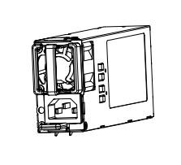

For different use environments, the S8500E provides many types of power modules for power supply. The DC and AC power modules have the same appearance, except for the front panel.

Figure 1-7 Power Module Appearance

DC power supply
If the DC power supply is adopted, the DC power supply should be 48V. The allowable range of input power is 36V~72V. The maximum output power is 350W or 550W. The power of S8510E can be up to 1300W.
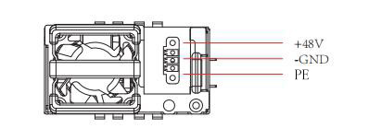
Figure 1-8 DC Power Supply Front Panel

AC power supply
If the AC power supply is adopted, the input voltage should be 220V. The allowable range of input power is 100V~240V, 50/60Hz. The max output power of the AC power module is 1300W or 550W or 350W.
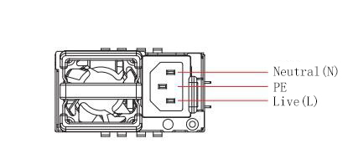
Figure 1-9 AC Power Supply Front Panel
S8500E provides multiple power configuration resolutions which vary with different requirements: users can use one DC/AC power supply module, or use several DC/AC power supply modules alone, or use several DC power supply modules plus several AC power supply modules. For details, please refer to the technical support configuration according to the specific board situation.

Ventilation and Cooling System
The working temperature of S8500E is 0°C to 40°C. The temperature in the appearance of one device cannot be higher than the 50% to 80% of the highest temperature of the device itself to keep the device reliable, secure and easy to maintain.
The device adopts the fan for air exhaust and mandatory convection, ensuring the device to run normally in the regulated conditions. The ventilation and heat dissipation convection scheme is shown in Figure 1-10.
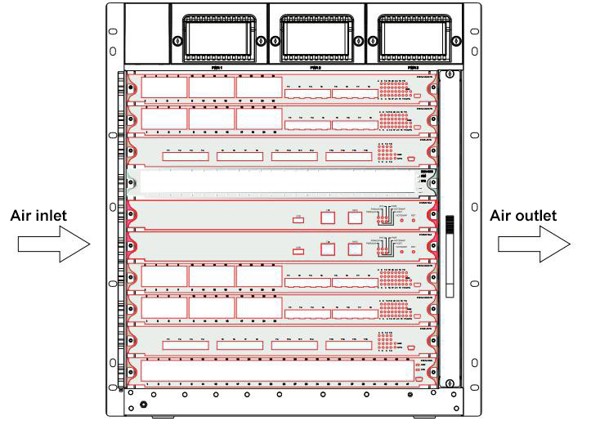
Figure 1-10 S8500E ventilation and heat dissipation convection scheme diagram

S8500E switch has two channels for ventilation and heat dissipation. One is the ventilation and heat dissipation channel for the system board with the fan board on the right side of the chassis, the hot air outlet on the right side of the chassis, and the cold air inlet on the left side of the chassis, as shown above. The other heat dissipation channel is the power module ventilation and heat dissipation channel. The power module has its own fan, which adopts the air extraction method. The front panel of the power supply has an air inlet, and the air outlet is located on the rear panel of the chassis.

Introduction to S8500E Single Board
S8500E has 11 types of single board which are described as follows:
- Main control board (ES85-MSU-I): It is the centralized control center module of S8500E, which is to conduct L2, L3 protocol processing, routing management, control and management of user access, network and operation and maintenance functions. It is adaptable to S8506E, S8510E.
- Main control board (ES85-MSU-II): It is the centralized control center module of S8500E, which is to conduct L2, L3 protocol processing, routing management, control and management of user access, network and operation and maintenance functions. It is adaptable to S8510E.
- 48-port GE TX port module (ES85-48GT): It provides with 48 GE RJ45 ports and supports 10/100/1000Mbps. It can realize the layer-2 switching and layer-3 routing function of the port. It connects to the core layer or the access layer, realizing port or user QoS.
- 48-port GE SFP port module (ES85-48GS): It provides with 48 GE SFP ports and supports 100/1000Mbps or 1000Mbps. It can realize the layer-2 switching and layer-3 routing function of the port. It can connect to the core layer or access layer, realizing port or user QoS.
- 48-port GE TX/SFP port module (ES85-24GS24GT): It provides with 24 GE SFP ports supporting 1000Mbps and 24 GE RJ45 ports supporting 10/100/1000Mbps. It can realize the layer-2 switching and layer-3 routing function of the port. It can connect to the core layer or access layer, realizing port or user QoS.
- 24-port GE SFP and 8-port 10GE SFP+ port module (ES85-24GS8TS): It provides with 24 GE SFP ports and 8 10GE SFP+ ports. It can realize the layer-2 switching and layer-3 routing function of the port. It can connect to the core layer or access layer, realizing port or user QoS.
- 24-port GE TX and 8-port 10GE SFP+ port module (ES85-24GT8TS): It provides with 24 GE TX ports and 8 10GE SFP+ ports. It can realize the layer-2 switching and layer-3 routing function of the port. It can connect to the core layer or access layer, realizing port or user QoS.
- 16-port 10GE SFP+ port module (ES85-16TS): It provides with 16 10GE SFP+ ports and supports 10GE SFP+ optical module. It can realize the layer-2 switching and layer-3 routing function of the port. It can connect to the core layer or access layer, realizing port or user QoS.
- 4-port 40GE QSFP port module (ES85-4QS): It provides with 4 40GE QSFP ports. It can realize the layer-2 switching and layer-3 routing function of the port. It can connect to the core layer or access layer, realizing port or user QoS.
- 24-port GE TX and 8-port 10GE SFP+ 03 main control board (ES8503-MSU-24GT8TS): It is the centralized control center module of S8503E, which is to conduct L2, L3 protocol processing, routing management, control and management of user access, network and operation and maintenance functions. It provides with 24 GE RJ45 ports supporting 10/100/1000Mbps and 8 10GE SFP+ ports.
- 24-port GE SFP and 8-port 10GE SFP+ 03 main control board (ES8503-MSU-24GS8TS): It is the centralized control center module of S8503E, which is to conduct L2, L3 protocol processing, routing management, control and management of user access, network and operation and maintenance functions. It provides with 24 GE SFP ports supporting 100/1000Mbps and 8 10GE SFP+ ports.

Main Control Board (ES85-MSU-I)
Figure 1-11 is the schematic diagram of the main control board (ES85-MSU-I). ES85-MSU-I is the main control board of S8500E, which is responsible for the system status control, routing management, user access control and management, and network maintenance. The exchange capacity is 640Gbit/s. ES85-MSU-I is adaptable to S8506E or S8510E.
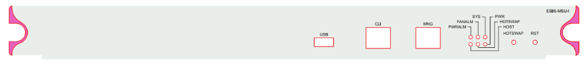
Figure 1-11 Schematic diagram of the main control board (ES85-MSU-I)

Interface
The ES85-MSU-I board provides with three types of interfaces:
- Console serial interface: the communication serial interface with the RS-232 capacitance and the RJ45 connector. The console serial interface is used to connect the terminal computers for systematic debugging, configuration, maintenance, management and software download.
- MNG port: a 1000M Ethernet port, with the RJ45 connector. The MNG port is used to connect the computers for program downloading, and also used to connect the remote network manager workstation to realize the remote management.
For the remote device management, you can adopt the standard network cable to connect to the HUB, then connect the HUB to the network management workstation on LAN; you can also connect the standard network cable to the router and then to the network management workstation on the WAN.
- USB interface: It can be used to connect to the USB device.

Indicator
The ES85-MSU-I board provides with 6 LED indicators, the description of which is shown in the following table:
Table 1-1 Description of Indicators in ES85-MSU-I
Indicator | Description
PWR | If the green indicator is on, the MSU is powered on normally.  If the green indicator is off, the MSU is not powered on.
SYS | If the green indicator is on, the MSU runs normally.  If the green indicator is off, the board can be pulled out.
HOST | If the green indicator is on, the MSU is in the master control state.  If the green indicator is off, the MSU is in a non-master state.
PWRALM | If the red indicator is on, the power supply of the system has alarmed.  If the red indicator is off, the power supply of the system is normal.
FANALM | If the red indicator is on, the fan of the system has alarmed.  If the red indicator is off, the fan of the system is normal.
HOTSWAP | If the indicator is on, it means that the MSU can be hot-swappable.

3. BUTTON Description
Table 1-2 Description of Buttons in the ES85-MSU-I
Name | Description
RST | Reset button, Reset the single board
HOTSWAP | Used for hot swap. When use two ES85-MSU-I modules; one operates at Master status and the other operates at Slave status. Long press the HOTSWAP key of the Master ES85-MSU-I board for 2S and release it, the Master ES85-MSU-I board will switch to the Slave state, and the Slave ES85-MSU-I board will switch to the Master state. The system will light the SWAP LED, then the MCU module can be hot plugged out.

Main Control Board (ES85-MSU-II)
Figure 1-12 is the schematic diagram of the main control board (ES85-MSU-II). ES85-MSU-II is the main control board of S8500E, which is responsible for the system status control, routing management, user access control and management, and network maintenance. The exchange capacity is 1.44Tbit/s. ES85-MSU-II is only adaptable to ES8510.
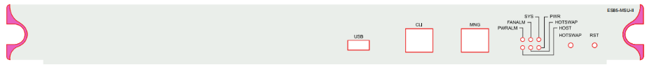
Figure 1-12 Schematic diagram of the main control board (ES85-MSU-II)

Interface
The ES85-MSU-II board provides with three types of interfaces:
- Console serial interface: the communication serial interface with the RS-232 capacitance and the RJ45 connector. The console serial interface is used to connect the terminal computers for systematic debugging, configuration, maintenance, management and software download.
- MNG port: a 1000M Ethernet port, with the RJ45 connector. The MNG port is used to connect the computers for program downloading, and also used to connect the remote network manager workstation to realize the remote management.
- For the remote device management, you can adopt the standard network cable to connect to the HUB, then connect the HUB to the network management workstation on LAN; you can also connect the standard network cable to the router and then to the network management workstation on the WAN.
- USB interface: It can be used to connect to the USB device.

Indicator
The ES85-MSU-II board provides with 6 LED indicators, the description of which is shown in the following table:
Table 1-3 Description of Indicators in ES85-MSU-II
Indicator | Description
PWR | If the green indicator is on, the MSU is powered on normally.  If the green indicator is off, the MSU is not powered on.
SYS | If the green indicator is on, the MSU runs normally.  If the green indicator is off, the board can be pulled out.
HOST | If the green indicator is on, the MSU is in the master control state.  If the green indicator is off, the MSU is in a non-master state.
PWRALM | If the red indicator is on, the power supply of the system has alarmed.  If the red indicator is off, the power supply of the system is normal.
FANALM | If the red indicator is on, the fan of the system has alarmed.  If the red indicator is off, the fan of the system is normal.
HOTSWAP | If the indicator is on, it means that the MSU can be hot-swappable.

BUTTON Description
Table 1-4 Description of Buttons in the ES85-MSU-II
Name | Description
RST | Reset button, Reset the single board
HOTSWAP | Used for hot swap. When use two ES85-MSU-I modules; one operates at Master status and the other operates at Slave status. Long press the HOTSWAP key of the Master ES85-MSU-I board for 2S and release it, the Master ES85-MSU-I board will switch to the Slave state, and the Slave ES85-MSU-I board will switch to the Master state. The system will light the SWAP LED, then the MCU module can be hot plugged out.

48-port GE TX Port Module (ES85-48GT)
Figure 1-13 shows schematic diagram of the 48-port GE TX port module (ES85-48GT). The board performs Layer 2 & Layer 3 wire-speed switching, ports trunking, connecting core layer and access layer, enables port and user QoS.
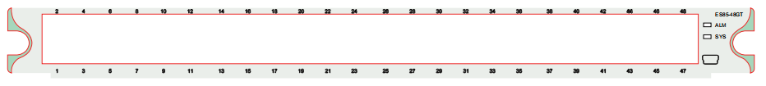
Figure 1-13 Schematic diagram of 48-port GE Base-T Port Module
- Interface
- ES85-48GT board provides with 48 gigabit Ethernet Base-T interfaces. The 10/100/100M Base-T interface supports the RJ45 interface mode.
- Provides one debugging serial port for single board debugging, which is not open for the clients.
- Indicator
Table 1-5 Description of Indicators in the ES85-48GT
Location | Name | Description
Above of RJ45 port | LINK/ACT | If the green indicator is on, the port has been appropriately connected with the device in the opposite terminal. The port is in “UP” state.  If the green indicator is off, the port is in “DOWN” (non-working) state.  If the green indicator flickers, there is data transmission in the port.
Right side of the panel | ALM | If the red indicator is on, the alarm occurs in the single board.  If the red indicator is off, the board runs normally.
Right side of the panel | SYS | If the green indicator flickers, the module runs normally.

48-port GE SFP Port Module (ES85-48GS)
Figure 1-14 shows schematic diagram of the 48-port GE SFP port module (ES85-48GS). The board performs Layer 2 & Layer 3 wire-speed switching, ports trunking, connecting core layer and access layer, enables port and user QoS.
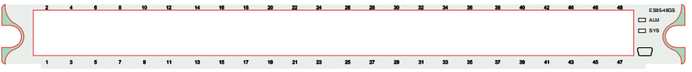
Figure 1-14 Schematic diagram of 48-port GE SFP port module (ES85-48GS)
- Interface
- ES85-48GS provides with 48 GE SFP ports.
- Provides one debugging serial port for single board debugging, which is not open for the clients.

Indicator
Table 1-6 Description of Indicators in ES85-48GS
Location | Name | Description
Below the SFP port | LINK/ACT | If the green indicator is on, the port has been appropriately connected with the device in the opposite terminal. The port is in “UP” state.  If the green indicator is off, the port is in “DOWN” (non-working) state.  If the green indicator flickers, there is data transmission in the port.
Right side of the panel | ALM | If the red indicator is on, the alarm occurs in the single board.  If the red indicator is off, the board runs normally.
Right side of the panel | SYS | If the green indicator flickers, the module runs normally.

48-port GE TX/SFP Port Module (ES85-24GS24GT)
Figure 1-15 shows schematic diagram of the 48-port GE TX/SFP port module (ES85-24GS24GT). The board performs Layer 2 & Layer 3 wire-speed switching, ports trunking, connecting core layer and access layer, enables port and user QoS
Figure 1-15 Schematic diagram of 48-port GE TX/SFP Port Module (ES85-24GS24GT)

Interface
- ES85-24GS24GT provides with 24 GE TX ports and 24 GE SFP ports.
- Provides one debugging serial port for single board debugging, which is not open for the clients.

Indicator
Table 1-7 Description of Indicators of ES85-24GS24GT
Location | Name | Description
Above the RJ45 port or below the SFP port | LINK/ACT | If the green indicator is on, the port has been appropriately connected with the device in the opposite terminal. The port is in “UP” state.  If the green indicator is off, the port is in “DOWN” (non-working) state.  If the green indicator flickers, there is data transmission in the port.
Right side of the panel | ALM | If the red indicator is on, the alarm occurs in the single board.  If the red indicator is off, the board runs normally.
Right side of the panel | SYS | If the green indicator flickers, the module runs normally.

24-port GE SFP and 8-port 10GE SFP+ port module (ES85-24GS8TS)
Figure 1-16 shows schematic diagram of 24-port GE SFP and 8-port 10GE SFP+ port module (ES85-24GS8TS). The board performs Layer 2 & Layer 3 wire-speed switching, ports trunking, connecting core layer and access layer, enables port and user QoS.
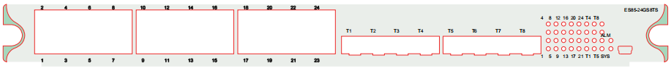
Figure 1-16 Schematic diagram of 24-port GE SFP and 8-port 10GE SFP+ port module (ES85-24GS8TS)

Interface
- ES85-24GS8TS provides with 24 GE SFP ports and 8 10GE SFP+ ports.
- Provides one debugging serial port for single board debugging, which is not open for the clients.

Indicator
Table 1-8 Description of Indicators in ES85-24GS8TS
Location | Name | Description
Right side of the panel | LINK/ACT | If the green indicator is on, the port has been appropriately connected with the device in the opposite terminal. The port is in “UP” state.  If the green indicator is off, the port is in “DOWN” (non-working) state.  If the green indicator flickers, there is data transmission in the port.
Right side of the panel | ALM | If the red indicator is on, the alarm occurs in the single board.  If the red indicator is off, the board runs normally.
Right side of the panel | SYS | If the green indicator flickers, the module runs normally.

24-port GE TX and 8-port 10GE SFP+ port module (ES85-24GT8TS)
Figure 1-17 shows schematic diagram of the 24-port GE TX and 8-port 10GE SFP+ port module (ES85-24GT8S). The board performs Layer 2 & Layer 3 wire-speed switching, ports trunking, connecting core layer and access layer, enables port and user QoS.
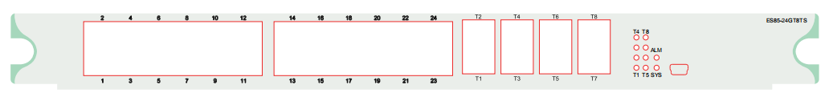
Figure 1-17 Schematic diagram of the 24-port GE TX and 8-port 10GE SFP+ port module (ES85-24GT8TS)

Interface
- ES85-24GT8TS provides with 24 GE TX ports and 8 10GE SFP+ ports.
- Provides one debugging serial port for single board debugging, which is not open for the clients.

Indicator
Table 1-9 Description of Indicators in ES85-24GT8TS
Location | Name | Description
Above the RJ45 port or right side of the panel | LINK/ACT | If the green indicator is on, the port has been appropriately connected with the device in the opposite terminal. The port is in “UP” state.  If the green indicator is off, the port is in “DOWN” (non-working) state.  If the green indicator flickers, there is data transmission in the port.
Right side of the panel | ALM | If the red indicator is on, the alarm occurs in the single board.  If the red indicator is off, the board runs normally.
Right side of the panel | SYS | If the green indicator flickers, the module runs normally.

16-port 10GE SFP+ Port Module (ES85-16TS)
Figure 1-18 shows schematic diagram of the 16-port 10GE SFP+ Port Module (ES85-16TS). The board performs Layer 2 & Layer 3 wire-speed switching, ports trunking, connecting core layer and access layer, enables port and user QoS.
Figure 1-18 Schematic diagram of the 16-port 10GE SFP+ Port Module (ES85-16TS)
      - Interface
- ES85-16TS board provides with 16 10GE SFP+ interfaces and supports 10GE SFP+ optical modules.
- Provides one debugging serial port for single board debugging, which is not open for the clients.
      - Indicator
Table 1-10 Description of Indicators in the ES85-16TS Board
Location | Name | Description
Right side of the panel | LINK/ACT | If the green indicator is on, the port has been appropriately connected with the device in the opposite terminal. The port is in “UP” state.  If the green indicator is off, the port is in “DOWN” (non-working) state.  If the green indicator flickers, there is data transmission in the port.
Right side of the panel | ALM | If the indicator is on, the alarm occurs in the single board.  If the indicator is off, the board runs normally.
Right side of the panel | SYS | If the green indicator flickers, the module runs normally.

4-port 40GE QSFP port module (ES85-4QS)
Figure 1-19 shows schematic diagram of 4-port 40GE QSFP port module (ES85-4QS). The board performs Layer 2 & Layer 3 wire-speed switching, ports trunking, connecting core layer and access layer, enables port and user QoS.

Figure 1-19 Schematic diagram of 4-port 40GE QSFP port module (ES85-4QS)

Interface
- ES85-4QS provides 4 40G QSFP ports and supports QSFP 40G optical module.
- Provides one debugging serial port for single board debugging, which is not open for the clients.

Indicator
Table 1-11 Description of Indicators in ES85-4QS
Location | Name | Description
Above the QSFP port | LINK/ACT | If the green indicator is on, the port has been appropriately connected with the device in the opposite terminal. The port is in “UP” state.  If the green indicator is off, the port is in “DOWN” (non-working) state.  If the green indicator flickers, there is data transmission in the port.
Right side of the panel | ALM | If the red indicator is on, the alarm occurs in the single board.  If the red indicator is off, the board runs normally.
Right side of the panel | SYS | If the green indicator flickers, the module runs normally.

24-port GE TX and 8-port 10GE SFP+ 03 main control board (ES8503-MSU-24GT8TS)
Figure 1-20 shows schematic diagram of the 24-port GE TX and 8-port 10GE SFP+ 03 main control board (ES8503-MSU-24GT8TS). The board performs Layer 2 & Layer 3 wire-speed switching, ports trunking, connecting core layer and access layer, enables port and user QoS.
Figure 1-20 Schematic diagram of the 24-port GE TX and 8-port 10GE SFP+ 03 main control board (ES8503-MSU-24GT8TS)

Interface
- ES8503-MSU-24GT8TS provides 24 GE TX ports and 8 10GE SFP+ ports and supports SFP+ 10GE optical module.
- Console serial interface: the communication serial interface with the RS-232 capacitance and the RJ45 connector. The console serial interface is used to connect the terminal computers for systematic debugging, configuration, maintenance, management and software download.
- MNG port: a 1000M Ethernet port, with the RJ45 connector. The MNG port is used to connect the computers for program downloading, and also used to connect the remote network manager workstation to realize the remote management.
For the remote device management, you can adopt the standard network cable to connect to the HUB, then connect the HUB to the network management workstation on LAN; you can also connect the standard network cable to the router and then to the network management workstation on the WAN.
- USB interface: It can be used to connect to the USB device.

Indicator
Table 1-12 Description of Indicators in ES8503-MSU-24GT8TS
Location | Name | Description
Above the RJ45 port or right side of the panel | LINK/ACT | If the green indicator is on, the port has been appropriately connected with the device in the opposite terminal. The port is in “UP” state.  If the green indicator is off, the port is in “DOWN” (non-working) state.  If the green indicator flickers, there is data transmission in the port.
Right side of the panel | PWR | If the green indicator is on, the MSU is powered on normally.  If the green indicator is off, the MSU is not powered on.
Right side of the panel | SYS | If the green indicator is on, the MSU runs normally.  If the green indicator is off, the board can be pulled out.
Right side of the panel | HOST | If the green indicator is on, the MSU is in the master control state.  If the green indicator is off, the MSU is in a non-master state.
Right side of the panel | PWRALM | If the red indicator is on, the power supply of the system has alarmed.  If the red indicator is off, the power supply of the system is normal.
Right side of the panel | FANALM | If the red indicator is on, the fan of the system has alarmed.  If the red indicator is off, the fan of the system is normal.
Right side of the panel | HOTSWAP | If the indicator is on, it means that the MSU can be hot-swappable.

24-port GE SFP and 8-port 10GE SFP+ 03 main control board (ES8503-MSU-24GS8TS)
Figure 1-21 shows schematic diagram of the 24-port GE SFP and 8-port 10GE SFP+ 03 main control board (ES8503-MSU-24GS8TS). The board performs Layer 2 & Layer 3 wire-speed switching, ports trunking, connecting core layer and access layer, enables port and user QoS.
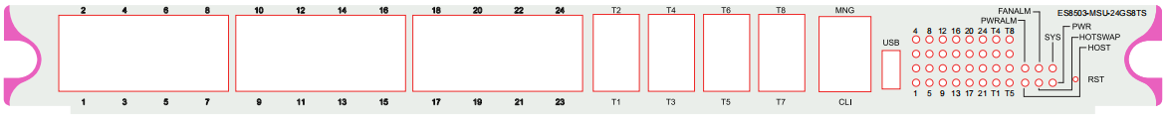
Figure 1-21 Schematic diagram of the 24-port GE SFP and 8-port 10GE SFP+ 03 main control board (ES8503-MSU-24GS8TS)

Interface
- ES8503-MSU-24GS8TS provides 24 GE SFP ports and 8 10GE SFP+ ports and supports SFP+ 10GE optical module.
- Console serial interface: the communication serial interface with the RS-232 capacitance and the RJ45 connector. The console serial interface is used to connect the terminal computers for systematic debugging, configuration, maintenance, management and software download.
- MNG port: a 1000M Ethernet port, with the RJ45 connector. The MNG port is used to connect the computers for program downloading, and also used to connect the remote network manager workstation to realize the remote management.
For the remote device management, you can adopt the standard network cable to connect to the HUB, then connect the HUB to the network management workstation on LAN; you can also connect the standard network cable to the router and then to the network management workstation on the WAN.
- USB interface: It can be used to connect to the USB device.

Indicator
Table 1-13 Description of Indicators in ES8503-MSU-24GS8TS
Location | Name | Description
Right side of the panel | LINK/ACT | If the green indicator is on, the port has been appropriately connected with the device in the opposite terminal. The port is in “UP” state.  If the green indicator is off, the port is in “DOWN” (non-working) state.  If the green indicator flickers, there is data transmission in the port.
Right side of the panel | PWR | If the green indicator is on, the MSU is powered on normally.  If the green indicator is off, the MSU is not powered on.
Right side of the panel | SYS | If the green indicator is on, the MSU runs normally.  If the green indicator is off, the board can be pulled out.
Right side of the panel | HOST | If the green indicator is on, the MSU is in the master control state.  If the green indicator is off, the MSU is in a non-master state.
Right side of the panel | PWRALM | If the red indicator is on, the power supply of the system has alarmed.  If the red indicator is off, the power supply of the system is normal.
Right side of the panel | FANALM | If the red indicator is on, the fan of the system has alarmed.  If the red indicator is off, the fan of the system is normal.
Right side of the panel | HOTSWAP | If the green indicator is on, the MSU is powered on normally.  If the green indicator is off, the MSU is not powered on.

Installation Preparation

Safety Advice
To prevent personnel and devices from harms, read safety advices in the manual before you install the BDCOM S8500E switch.
The following safety advices do not cover all potential dangers.

Safety Advices for System Installation
- Keep the hull clean and dustless.
- Do not put the device at the walking area.
- Do not wear loose clothes or other things that may be tumbled by the machine box during installation and maintenance.
- Before dismantling the hull, please shut down all powers and plug out all power supplys and cables.

Safety Advices for Removal
Because S8500E has a large volume and weighs heavy, please follow the following requirements during carrying S8500E:
- Do not remove S8500E frequently, as the whole device of S8500E weighs about 70kg.
- At least two persons are needed if S8500E requires to be moved.
- When you move the device, watch your feet or your waist.
- Before moving the device, cut off all power supplies and plug out all cables.
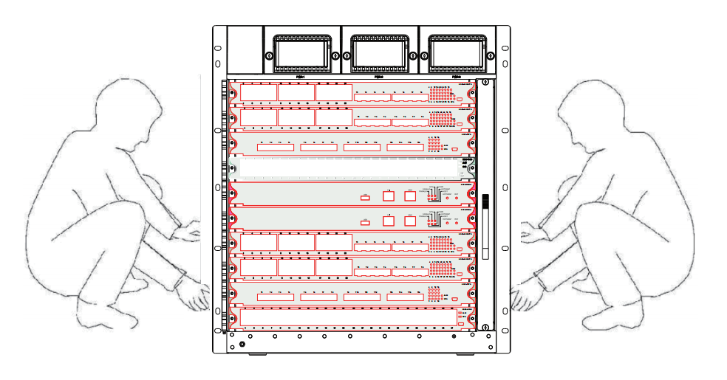
Figure 2-1 Moving S8500E Correctly
 When moving the device, do not hold the board, power handle or ventilation hole.

Electricity Security
- Check potential dangers in the working area, such as ungrounded power supply, unreliable power grounding and wet ground.
- Before installation, know the location of the emergency power switch indoors. If trouble occurs, cut off the power.
- Try to avoid maintaining the devices alone.
- When the power is cut off, check the devices carefully.
- Do not put the device in moist environment or let liquid substance into the hull.
- Follow instructions to connect the positive/negative line before the DC power is used.

Static Discharge Prevention
Although many measures are taken on S8500E for preventing the static, the static still has bad effect on the circuits and devices when the static reaches a certain volume.
The following are the main resources of the static when S8500E connects the communication network:

- Outside electric fields like outdoor hi-voltage wire and thunder
- Inside systems such as the floor materials and the architecture of machines
To prevent the static's damage, do as follows:
- The device and the floor are well grounded.
- Prevent the dust indoors.
- Keep proper humidity.
- Wear the static-free armguard before you touch the circuit board.
Do as follows when the board is replaced or installed:
- Before installing all kinds of parts, especially the circuit board, wear the static-free armguard.
- When you have to hold the circuit board, hold its edges. Forbid to touch the elements and the printing circuit.
- Prevent clothes from touching the circuit board. The static-free armguard can only prevent the static in the body from damaging the circuit board, while it cannot prevent the static in the clothes.

Laser Security
- When the optical-fiber transceiver works, you should make sure that the port connects the optical-fiber cable and that the port is stuffed by the anti-dust lid.
- Do not look the laser interface in the eye.

Requirements for Location Place
BDCOM S8500E switch must be installed indoors. To secure its normal running and expand its lifespan, the following requirements for the installation place must be satisfied:

Requirements for Stand Installation
To install S8500E in a stand, make sure that the machine box meets the following requirements:
- Try to install it in an open stand. If it is installed in a closed stand, make sure that the ventilation of the stand is good.
- Make sure that the stand is strong enough to support S8500E and its accessories.
- Make sure that the size of the machine box is proper so that there is certain space for heat dissipation after S8500E is installed.
- The machine box is well grounded.

Ventilation Requirements
The ventilation of the device must guarantee space reservation at the ventilation hole, as shown in figure 2-2, enabling the cooling system to works normally. After all types of cables are connected, you should bind them together to prevent them from stuffing the ventilation hole.
Notes:
No plugging the module slot must be fitted with fake handle bar, to ensure that the air duct is smooth.
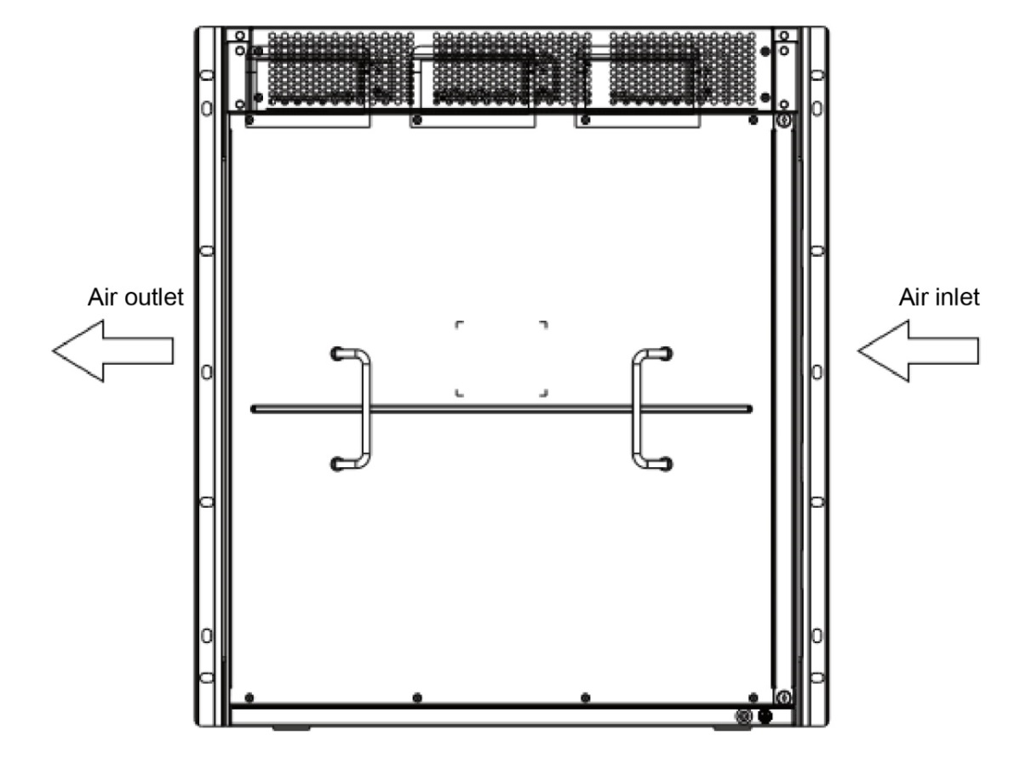
Figure 2-2 Ventilation mode of S8500E

Temperature and Humidity
To guarantee the normal function and lifespan of BDCOM S8500E switch, you should maintain a certain temperature and humidity in the machine room.
If the temperature and humidity in the machine room is unsuitable for a long time, the device may get damaged.
- In a relatively high humid environment, the insulation material may not insulate well, or even have current leakage. In some cases, the mechanic performance of the material and mental parts’ erosion may occur.
- In a relatively low humid environment, the insulation slice may be dried, shrink and easily generate static; hence, the circuits on the device may get damaged.
- The higher the temperature, the greater the danger is. The reliability of the switch, hence, will greatly be affected and the aging process of the switch will be greatly accelerated.
The requirements for temperature and humidity are shown in table 2-1:
Table 2-1 BDCOM S8500E switch’s requirements for temperature and humidity
Temperature |  | Relative Humidity
Long-term working condition | Short-term working condition | Long-term working condition | Short-term working condition
15ºC-30ºC | 0ºC-60ºC | 40%-65% | 10%-90%
- The measurement should be taken at 1.5m high and 0.4m ahead of the front template when the bracket has no shield panes.
- The short-term function means that the switch cannot continuously run over 48 hours or 15 days discontinuously each year.
- The extremely bad working environment means the temperature and humidity when trouble occurs in the air-conditioning system. The switch may restore to its working condition if it exposed in the extreme environment is no more than 5 hours.

Cleanness Requirements
Dust is a danger for device’s function. If there are lots of dusts in the switch’s hull, the static may be absorbed and therefore the metal pointer may not be well touched, especially when the indoor humidity is relatively high. The dust volume and particle diameter in the machine room are shown in table 2-2.
Table 2-2 Dust volume and particle diameter in the machine room
Maximum diameter (μm) | 0.5 | 1 | 3 | 5
Maximum thickness (particle/m3) | 1.4 x 10 | 7 x 10 | 2.4 x 10 | 1.3 x 10
Besides the dust, the device has severe demands for the salt/acid/sulfide percentage in the air. These vicious substances will accelerate metal’s erosion and the aging process of some parts. Hence, vicious gases (SO2, H2S, NO2, and CL2) must be prevented from entering the computer room. The details about the maximum vicious gas percentage in the air are shown in table 2-3.
Table 2-3 Average/maximum vicious gas ratio in the air
Gas | Average ratio (mg/m) | Average ratio (mg/m)
SO2 | 0.2 | 1.5
H2s | 0.006 | 0.03
NO2 | 0.04 | 0.15
NH3 | 0.05 | 0.15
CL2 | 0.01 | 0.3

Power Requirements
- When S8500E adopts the AC power, the following conditions must be met:
Input AC voltage: AC 100V~240V, 50/60Hz
Power: 1300W
Input AC voltage: AC 100V~240V, 50/60Hz
Power: 550W
Input AC voltage: AC 100V~240V, 50/60Hz
Power: 350W
- When S8500E adopts the DC power, the following conditions must be met:
Input DC voltage: DC -36V~72V
Power: 1300W
Input DC voltage: DC -36V~72V
Power: 550W
Input DC voltage: DC -36V~72V
Power: 350W
The device provides the function of power supply backup. You are suggested to adopt the multi-path power supply so as to guarantee the continuous running of the device, preventing sudden power shutdown.

Grounding Requirements for the System
The nice grounding system is a solid base for BDCOM S8500E switch to function reliably, and a prima premise for thunder attack prevention and anti-jamming. Please carefully check the grounding conditions of the installation site according to the requirements of grounding regulations, and get the grounding well done according to actual situation.

Safe Grounding
The AC-adopted device must be grounded through the yellow-green grounding line, or the electric shock may occur when the insulation resistance between power supply and hull gets small.

Thunder Grounding
The anti-thunder system is an independent system among facilities, consisting of the lightning rod, the underground conductor and the connector for the grounding system. The grounding system is used together with the grounding device for the yellow-green safety grounding line. The lightning discharge grounding is just for facilities, not for devices.

Electromagnetic-Compatible Grounding
The groundings which are oriented for electromagnetic compatibility include the shielded grounding, filter grounding, noise/interruption limitation and level reference. The grounding resistance must be less than 1Ω.
The hull of BDCOM S8500E switch has one grounding column. See figure 2-3.
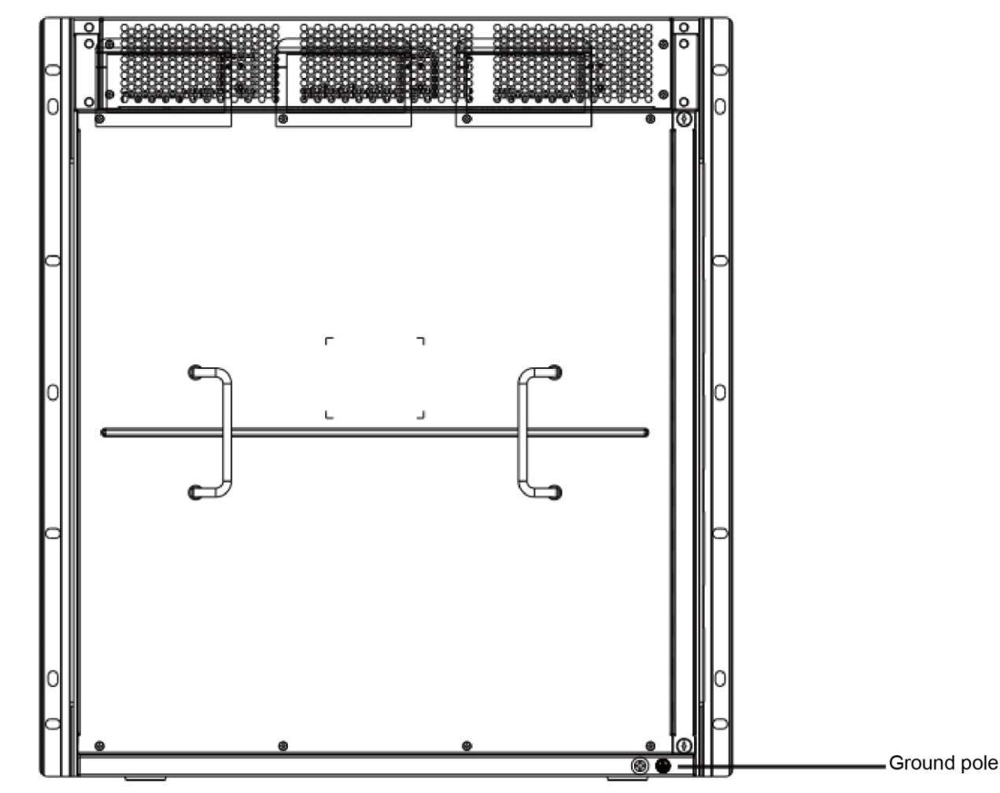
Figure 2-3 Grounding column of S8500E
The system connection is to guarantee the normal running of all devices. Please read the following before you connect all devices in the system.

EMI Precautions
All kinds of interference sources, no matter they are from the devices, the outside of the application system or the inner system, have effect on the devices through different conduction modes such as capacitance coupling, inductance coupling and electromagnetic wave radiation.
The electromagnetic interference is classified into two types: radiation interference and conduction interference, which is decided by the type of the diffuseness path.
The process that an energy ejected by a device (it is always the radio energy) reaches a sensor through space is called the radiation interference. The interference source can be a part of the disturbed system, or be a unit which is wholly isolated from electrical devices. The reason why the conduction interference generates is that the interference source connects the sensor through the electromagnetic line or the signal cable and the interference is conducted from one unit to another. The conduction interference always affects the power system of the device. Thus, the wave filter is required to stop the conduction interference from affecting the power system. The radiation interference can affect any signal path in the device, while the way to shield the radiation interference is difficult.
- Effective measures must be taken to prevent the grid from disturbing the power supply system.
- You'd better not put the grounding device of electrical equipment and the anti-thunder device on the ground where the switch lies. Try to keep a long distance between grounding/anti-thunder device and switch.
- Keep far away from the powerful wireless emission station, radar emission station or hi-frequency electric device.
- The static-shielding method must be taken.

Precautions for Optical Fiber Connection
Before connecting the optical fiber, make clear that the type of the optical connector and the type of the optical fiber comply with the adopted optical interface's type.

Installation Tools
Table 2-4 Tools and Apparatus
Regular tools | Phillips screwdriver, flat-blade screwdriver, spanner 10~12 metric, related cables and optical cables, mounting bolts, electric welding, diagonal pliers, strapping
Specific tools | Static-proof tools
Apparatus | Multimeter
S8500E has no accessory toolkit and users need prepare for these tools.

Requirements for Unpacking & Goods Examination
The switches are delivered according to the order contract, so the buyer has to unpack and check the switches according to the order contract.

Cargo List
a. Package box for device and machine box
- Check whether all kinds of templates of the device are installed and debugged or not.
- Check whether the power supply module of the device is the required AC/DC module.
- Check the power line and the grounding line of the device.
- Configure the cable and optical cable.
- Check the accessory documents.
- Check the packing list.
b. Package box for the panel
It contains the backup panel of S8500E.
The example above is a normal case for goods clearance. The actual goods clearance may differ. In this case, follow the requirements of the contract. Please check your goods according to the packing list and the order contract. If having problem, please contact the dealer.
c. Checking the shipping container
The package method of the shipping container is shown in Figure 2-4. After the shipping container is opened, check as follows:
- Check whether the shipping container has the required shock-free foam.
- Check whether the paper box in the shipping container is fine and whether the sealing is good.
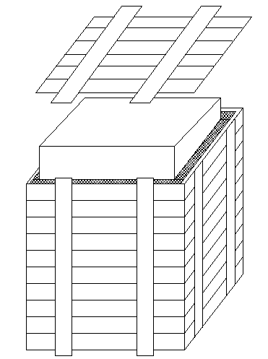
Figure 2-4 Package method for the shipping container

Recording the On-Site Log
After all containers are checked, put labels on the shipping containers and make corresponding records.
Each device must be prepared with an on-site log that should contain the following information: production date, debugging record, software/hardware version number, production line number.
Note:
- When you plug or plug out the power line, keep the power line horizontal with the power socket.
- When the lifetime of our products ends, handle them according to national laws and regulations, or send these products to our company for collective processing.

Installation of S8500E
- Before installing S8500E, read this chapter and Chapter 2 first.
- Requirements described in Chapter 2 have been met.

Installation Procedures
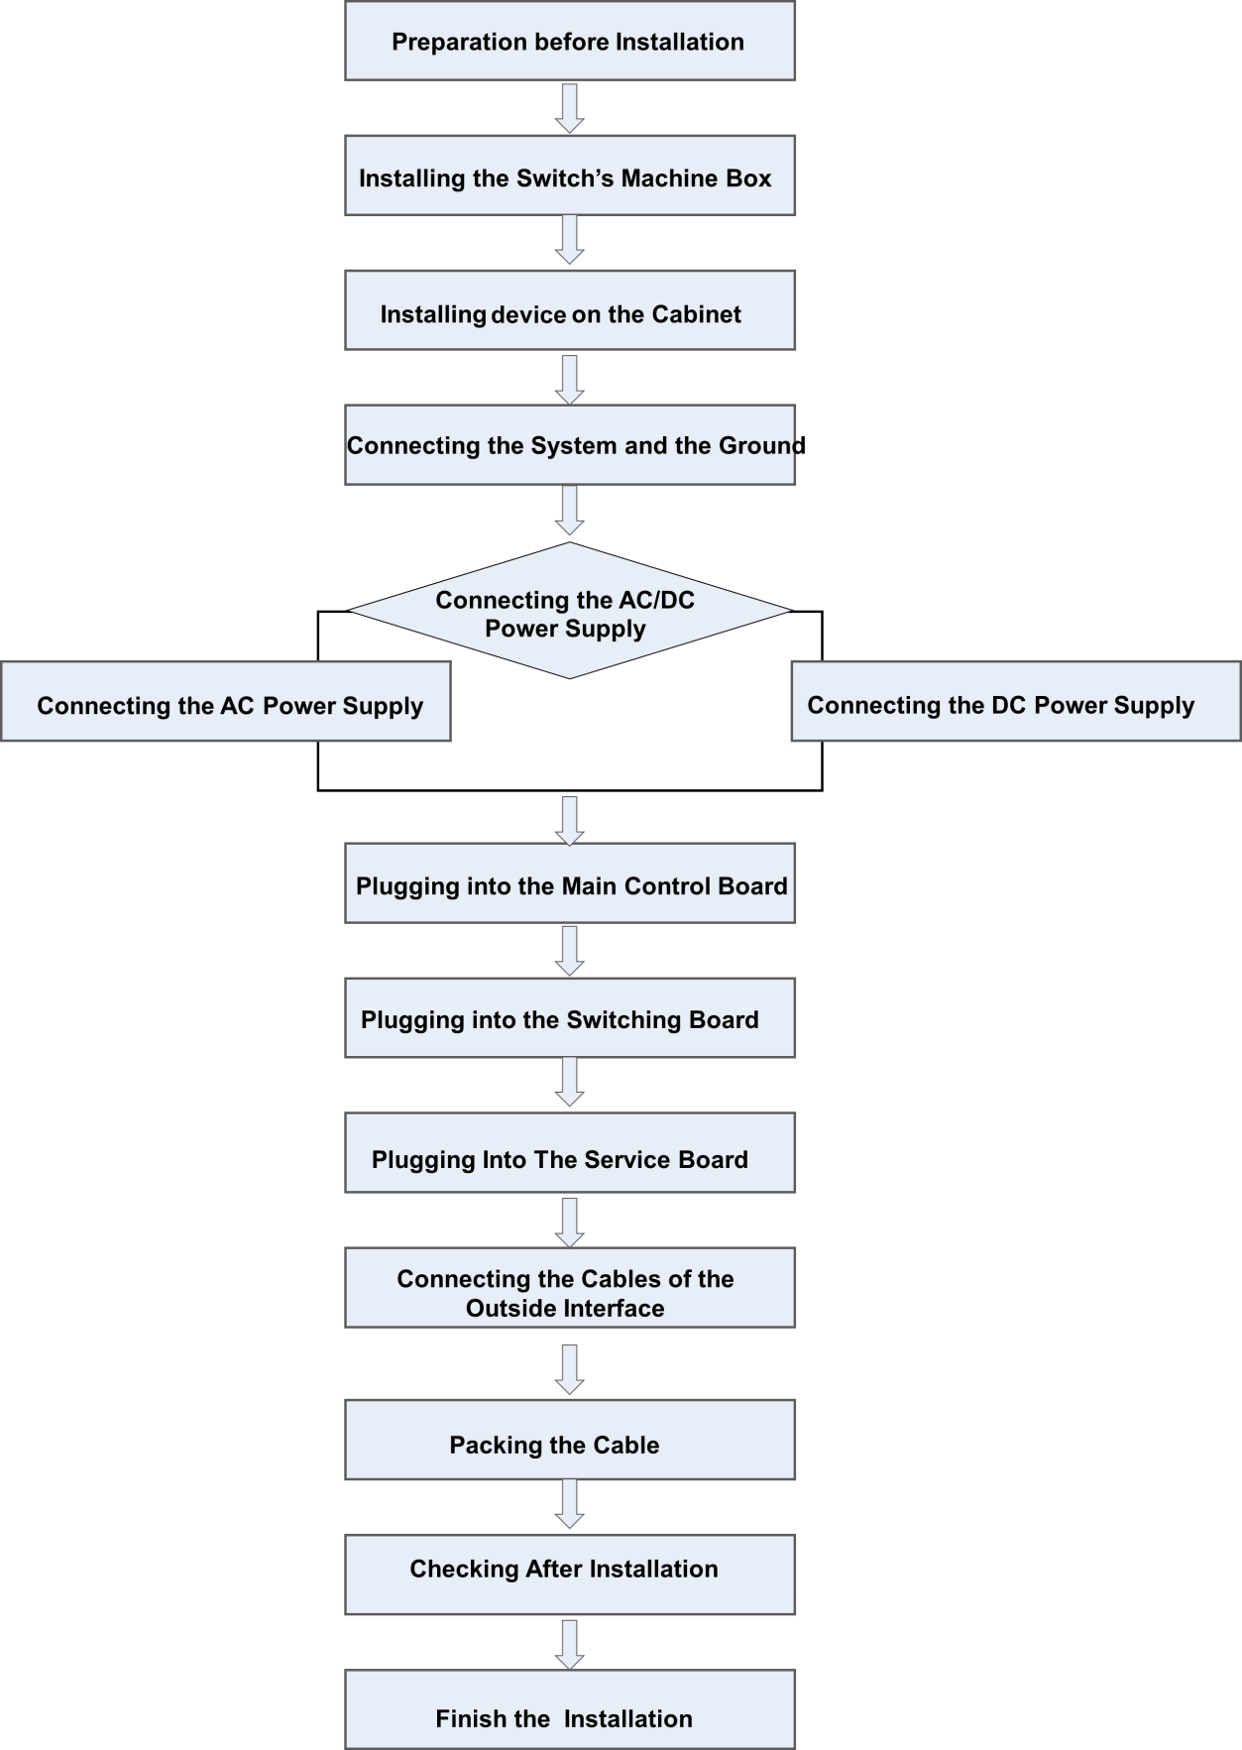

Preparation before Installation
Before installing BDCOM S8500E, you must have ideas in mind about the location site, networking mode, power supply and lining.
Do as follows before installing S8500E:
- Make a reserved place for ventilation.
- Check whether the power supply and the air flow at the installation site are prepared according to corresponding requirements.
- Check whether the cables are prepared well for the power supply and relative network.
- Decide whether to select the AC power or the DC power and check whether the rated power can be obtained.

Installing the Switch’s Machine box

Precautions
Note the following things when you install the cabinet:
- All bolts to fix the cabinet to the ground are well installed. You need wrench the bolt according to the order from bottom to top: flat pad, spring pad and nut.
- The cabinet is stable after installed.
- The cabinet should be vertical with the ground after installed.
- The cabinets installed in the machine room should be on a line. The error should be less than 5mm.
- The front door and the rear door of the cabinet should be convenient for opening or closing. The lock is fine and the keys are prepared.
- There are no redundant and abnormal labels in the cabinet or on each board.
- The fake handle should be installed well.
- The screws for fixing each device in the cabinet should be firm, complete and matched with the type of the bolt.
- Each board should be firmly installed and the screws to fix the templates are firmly wrenched.
- All cord outlets at the bottom or top of the cabinet need be installed with the rat prevention net. The diameter of the left leak cannot be more than 1.5cm, preventing rats or other little animals to enter the cabinet.
- The static-free armguard must be installed in the cabinet.

Installation Procedures
- Make a layout for space before installing the cabinet. Reserve much room for the front and rear doors of the cabinets for maintenance and operation.
- Install the 19-inch machine box on the designated location according to the layout and then fix it well.
- Install corresponding cable troughs and connection lines.
- Install corresponding salvers and the wire-start layer.

Installing S8500E on the Cabinet

Precautions
Before installing S8500E on the cabinet, check whether the front and rear fixing brackets of the cabinet is properly located. If the fixing brackets are not in a proper location, the front template of the device may be too close to the front door. The front door of the cabinet may not be closed after the network cable is plugged. Make sure of a distance of 10mm between the front door and the front template after S8500E is installed.
Additionally, the following things need be checked before installation:
The cabinet is well fixed and each module in the machine box has been installed. There is no barrier in the machine box or beside the machine box affecting the installation. The to-be-installed device is prepared well and moved to a place near the cabinet for easy removal.

Installation Procedures
- Two people horizontally hold the edges of S8500E and slowly carry it before the machine box.
- Two people move S8500E horizontally to a position slightly higher than the tray of the cabinet or the slide way and then insert it to the cabinet.
- Install the fixed bolts to fix S8500E to the inside of the cabinet. There are fixing notches on the left and right upper and lower sides of the front panel of the frame. Use screws to fix the device on the fixing bracket of the cabinet.

Connecting the System and the Ground
There is Protection Ground (PGND) on the back of S8500E. First, you connect PGND and the grounding column of the cabinet and then connect the grounding column and the grounding bar of the machine room. (If the ground bar is divided into a digital ground bar and an analog ground bar, then PGND is connected to the analog ground.)

Precautions
- The side size of the grounding line can be calculated through the passed maximum current load. The fine conductor and conduction line should be used.
- The unshielded conduction lines are forbidden to use.
- The grounding resistance value should be less than 1Ω.

Grounding Procedures
- Loose the six-angle screw on the rear grounding column.
- Lock the terminal of the grounding line to the grounding column.
- Wrench the six-angle screw with the spanner.
- Connect the corresponding terminals through the previous steps according to the connection map.

Connecting the DC Power Supply to the Power Supply Module
According to identifiers and location requirements on the template of the power supply module, connect the corresponding DC power line. For details, see the following figure.
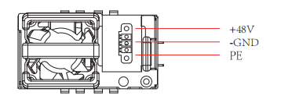
Figure 3-1 Schematic diagram of DC power connection

Precautions
- Before connecting the power supply, check whether the provided outside power supply matches up with the power supply module installed in S8500E.
- Check whether the switch of the power supply module is in shutdown state or not before connecting the power line.
- Connect the power line and the wire post according to the same color.
- Make sure that the connected power line is well conducted.

Connection Procedures
- Lock the power line to the corresponding post according to identifiers and then wrench the bolt.
- Connect the other end of the power line to the corresponding socket or connector.

Connecting the AC Power Supply to the Power Supply Module
Connect the corresponding DC power cables according to the markings on the power module panel and location requirements. See the connection method in the figure below for details.
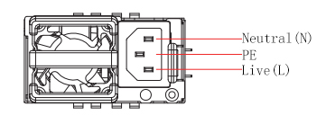
Figure 3-2 Schematic diagram of AC power connection

Precautions
- Before connecting the power supply, check whether the provided outside power supply matches up with the power supply module installed in S8500E.
- Check whether the switch of the power supply module is in shutdown state or not before connecting the power line.
- Connect the power line and the wire post according to the same color.
- Make sure that the connected power line is well conducted.

Connection Procedures
- Directly insert the plug of the power line into the power supply module.
- Connect the other end of the power line to the corresponding socket or connector.

Connecting the Cable of the Main Control Board

Connection Procedures
- Connect the RJ45 end of the Ethernet cable to the Ethernet interface of the ES85-MSU and then connect the other end of the Ethernet cable to the network manager device or the terminal control device.
- Connect the RJ45 end of the RS-232 serial cable to the RS-232 serial interface of the ES85-MSU and then connect the other end of the Ethernet cable to the network management device or the terminal control device.

Removing the Single Board Away from S8500E

Procedures for Removing the Single Board
- Plug out all optical fibers and cables from the template.
- Loose the two bolts on the template.
- Plug out the insertion board. See figure 3-3.
- When you conduct the previous procedures, please wear the static-free armguard and shut down the corresponding power first.
- Do not hold the edges of PCB or collide components of PCB.
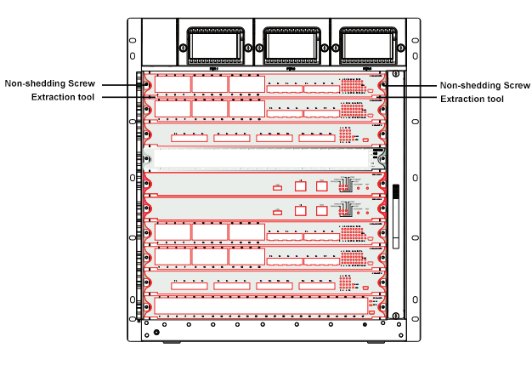
Figure 3-3 Components at the edge of the board

Reinstalling a Board on S8500E

Procedures for Reinstalling a Board
- Remove the card of the corresponding part according to actual requirements.
- Replace with the corresponding card and put it into the right slide way.
- Wrench the corresponding two screws after the card is pushed to the right position.
- Do not hold the edges of PCB or collide components of PCB.
- Use the corresponding tools when inserting or dialing out the PCB module. Here the harsh operation is forbidden.

Connecting the Cables of the Outside Interface

Precautions
- Tell the single-mode or multi-mode optical fiber from the interface.
- Prevent the connector from being abruptly curved.

Connection Procedures
Connect the RJ45 end of the Ethernet cable to the Ethernet interface of the device board and then connect the other end of the Ethernet cable to the network manager device or the terminal control device.
Connect the RJ45 end of the serial cable to the serial interface of the device board and then connect the other end of the Ethernet cable to the network manager device or the terminal control device.
According to the identifiers on the template, insert the single-mode or multi-mode optical fiber into the corresponding interface.
Connect the cables and fiber optic cables of each board in turn.

Packing the Cable

Precautions
- The power lines and the cables should be bound orderly and tidily.
- When packing the optical fiber, prevent the connector of the optical fiber from being curved.
- Do not pack optical fibers and cables too tightly to shorten their lifespan or weaken the transmission ability.

Packing Procedures
- Pack the drooped parts of optical fibers and cables and lead them to the two sides of the machine box conveniently.
- On the two sides of the machine box, fix optical fibers and cables to the wire slots.
- When packing the power lines, pack them tightly to the bottom of the machine box and keep them in a line.

Checking after Installation

Checking the Cabinet
- Check whether outside power supply matches up with the switchboard of the cabinet.
- After the switch is installed, check whether the front/reel cabinet doors can be closed.
- Make sure that the cabinet is so fixed that it cannot be removed or fall down.
- Make sure that the switch has been installed and fixed well in the cabinet and that all cables are also fixed on the cabinet.

Checking Cable Connection
- Make sure that the optical-fiber cable and the cable match the ports.
- Check whether the cables are bound correctly.

Checking the Power Supply
- Check whether the power line is well touched and complies with the security requirements.
- Make sure that the power supply module is wrenched tightly through two bolts on a template.
- Open the switch of the power supply and check whether the power module works normally.

Common Trouble Shooting during Installation

General Procedures for Trouble Shooting during Installation
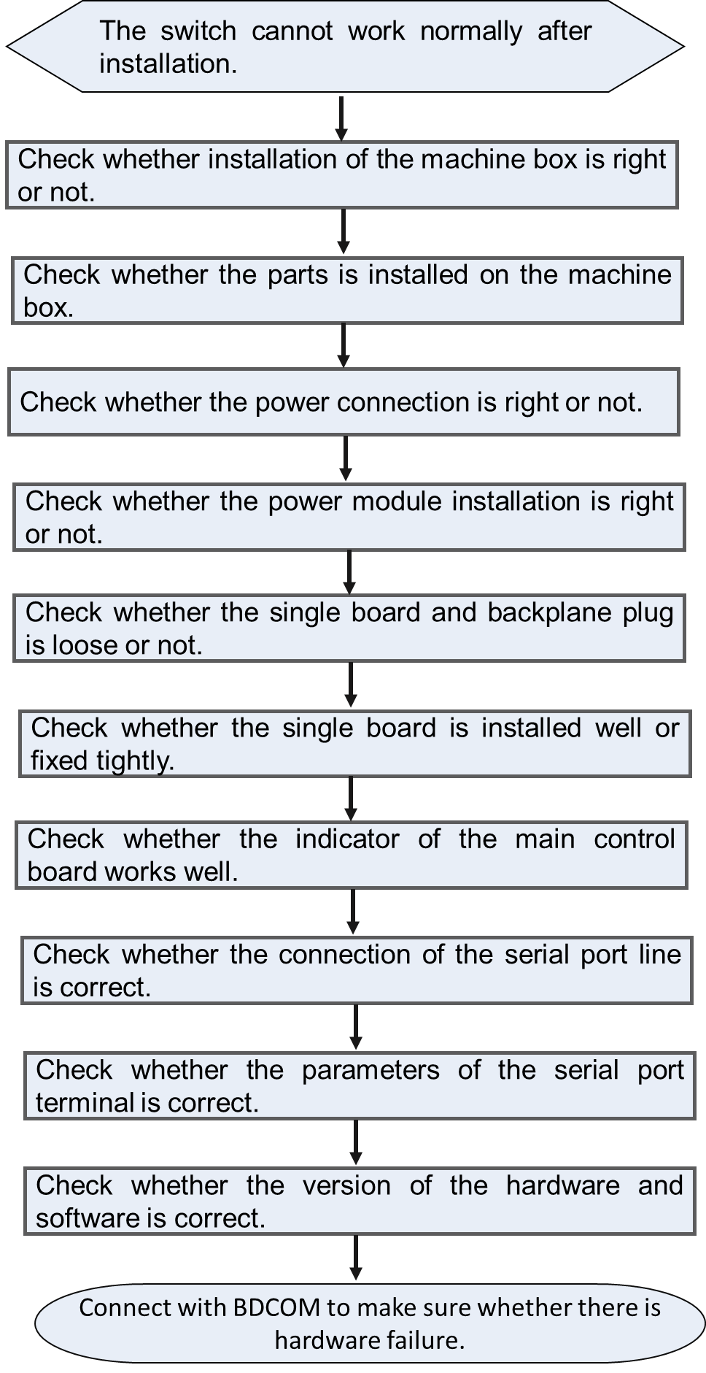

Trouble Shooting in Hardware Installation

Trouble Shooting in the Power Supply Module
Trouble 1: The AC power module cannot be powered.
- Trouble Description
The PWR indicator of each board is not on. The green indicator of the power module is off. The fan cannot run.
- Trouble Shooting Method
First, check whether the lines in the cabinet are correctly connected. Then check whether the AC feeder cable of the cabinet are correctly connected. If necessary, plug out the power supply module to check whether the connectors of the power system backplane are loosen.

Trouble 2: The DC power module cannot be powered.
- Trouble Description
The PWR indicator of each board is not on. The green indicator of the power module is off. The fan cannot run.
- Trouble Shooting Method
First, check whether the lines in the cabinet are correctly connected. Then check whether the DC feeder cable of the cabinet are correctly connected. If necessary, plug out the power supply module to check whether the connectors of the power system backplane are loosen.

Board Installation Troubles
Trouble 1: The indicator is abnormal after the board is powered.
- Trouble Description
The SYS indicator is always off, while the HOTSWAP indicator is always on.
- Trouble Shooting Method
Check whether the board is inserted tightly. If the board is not inserted tightly, reinstall the board, insert it tightly and then wrench fixed screws tightly. If the board cannot run after it is inserted tightly, check whether the connector on the slot-corresponding backplane is loose. If the connector is loose, you can put the board on other slots for re-test. If the fault still exists, return the board to its manufacturer for repair.

Trouble 2: The indicator is abnormal after the board runs a certain period of time.
- Trouble Description
The SYS indicator is always off, while the HOTSWAP indicator is always on.
- Trouble Shooting Method
Check whether the board is loose. If the board is not inserted tightly, reinstall the board, insert it tightly and then wrench fixed screws tightly. If the board cannot run after it is inserted tightly, check whether the connector on the slot-corresponding backplane is loosen and whether the slide track of this slot is deformed. If the connector is loose, you can put the board on other slots for re-test. If the fault still exists, return the board to its manufacturer for repair.

Appendix

Identifier, Package, Transmission and Storage of S8500E

Identifier of S8500E
- Product identifier: S8500E

Identifiers on the Outside Package
- Product model: S8500E
- Name of manufacturer: Shanghai BDCOM
- Production origin: Made in China
- Package identifier: comply with GB191-1990 Icons and Identifiers of Package & Storage.
- Delivery No.

Production Origin
Shanghai, China

Product Type
Network products

Package
Note: The glossaries must comply with related regulations in Electronic Product
Protection, Package and Package Level (SJ/Z3216-1989).

Basic Package Requirements
The package must comply with the regulations described in GB3873-1983 General Technical Conditions for Communications Product Package.

Package Materials
The inner package material of the device is plastic bag. At the two sides of the package box are EPE cascading foam plastics. The outside package material is corrugated paper box. Outside of the paper box, the wood box is used to strengthen the package. The EPE cascading foam plastics is used between the wood box and the paper box to prevent shocks. See figure 5-1.
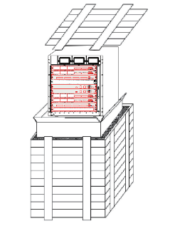
Figure 5-1 Device packaging

Shipping
- The products can be shipped by the ship, the plane or the automobile.
- The canopy is used to prevent rains during transportation.
- Load or unload the products gently.

Storage
- Storage field: Warehouse
- Storage conditions
Temperature: -25°C~55°C Humidity: 40%~90%
The air in the warehouse cannot contain caustic gases.
- Storage requirements
The outside package boxes can be piled with three layers.
- Storage period
The products can be stored for three years, while the stored products need be checked every two quarters.

Tools for Opening and Closing the Package Box
- Tools for opening the package box
Pries and knife
- Tools for the package
Knife, transparent glue, nail, hammer, packing strap, packer

Others

Accessory Files
Table 5-1 Accessory files
File Name | Content of the File
Product documents for users | S8500E Command Manual, S8500E Configuration Manual and S8500E Installation Manual.
Certificates | The delivery date, the signature or seal of the IQC which can be presented by the number ID of the IQC.
Warranty card | The warranty card includes the following contents:  1. Warranty conditions and period for free maintenance.  2. Warranty period which is calculated by month or by year according to the conditions of the product and also synchronizes with the warranty period of the maintenance office.  3. Warranty regulations for those products that cannot be maintain by the maintenance office.  4. Charge maintenance regulations for those products that exceed the warranty conditions and period.  5. A list of product service centers and maintenance offices.  6. Maintenance records (maintenance date, content and result).  7. Warranty card No. and information registration.

Accessory Cables
Console cables and power cords are packaged with the plastics bag.

Copyright ©Shanghai Baud Data Communication Co., LTD. 2021. All Rights Reserved.
No part of this manual may be reproduced or transmitted in any form or by any means without the prior written permission of Shanghai Baud Data Communication Co., LTD.

Trademark Notice
, BDCOM, and  are trademarks or registered trademarks of Shanghai Baud Data Communication Co., LTD. Other trademarks, product, service and company names mentioned are the property of their respective owners.

Disclaimer
Please note that the manual shown here are for reference purposes only. It does not constitute a legal contract or a commitment between BDCOM and any person or entity. Although every effort has been made to ensure all the information in this manual is correct, inaccuracies or typographical errors may still occur. In no event shall BDCOM be responsible or liable, directly or indirectly, for any damage or loss caused or alleged to be caused by or in connection with the manual.
BDCOM reserves the right to alter, update and otherwise change the information contained in the manual from time to time without notice.

